## MDC LMS DR Startup Steps

1. Access the MDC DR environment (using web Brower login Citrix VDI)
2. Check/Setup LMS network settings (Hostname, IP address, DNS)

$ hostname

admsrv1/admsrv2

$ ifconfig -a

en0: flags=1e080863,4c0<UP,BROADCAST,NOTRAILERS,RUNNING,SIMPLEX,MULTICAST,GROUPRT,64BIT,CHECKSUM_OFFLOAD(ACTIVE),LARGESEND,CHAIN>

inet 10.253.142.80 netmask 0xffffffc0 broadcast 10.253.142.127

tcp_sendspace 131072 tcp_recvspace 65536 rfc1323 1

en1: flags=1e080863,4c0<UP,BROADCAST,NOTRAILERS,RUNNING,SIMPLEX,MULTICAST,GROUPRT,64BIT,CHECKSUM_OFFLOAD(ACTIVE),LARGESEND,CHAIN>

inet 10.253.136.80 netmask 0xfffffe00 broadcast 10.253.137.255

tcp_sendspace 262144 tcp_recvspace 131072 rfc1323 1

en2: flags=1e080863,4c0<UP,BROADCAST,NOTRAILERS,RUNNING,SIMPLEX,MULTICAST,GROUPRT,64BIT,CHECKSUM_OFFLOAD(ACTIVE),LARGESEND,CHAIN>

inet 10.253.133.15 netmask 0xffffff80 broadcast 10.253.133.127

tcp_sendspace 131072 tcp_recvspace 65536 rfc1323 1

en3: flags=1e080863,4c0<UP,BROADCAST,NOTRAILERS,RUNNING,SIMPLEX,MULTICAST,GROUPRT,64BIT,CHECKSUM_OFFLOAD(ACTIVE),LARGESEND,CHAIN>

inet 10.253.133.138 netmask 0xffffff80 broadcast 10.253.133.255

inet 10.253.133.139 netmask 0xfffffe00 broadcast 10.253.133.255

tcp_sendspace 131072 tcp_recvspace 65536 rfc1323 1

lo0: flags=e08084b,c0<UP,BROADCAST,LOOPBACK,RUNNING,SIMPLEX,MULTICAST,GROUPRT,64BIT,LARGESEND,CHAIN>

inet 127.0.0.1 netmask 0xff000000 broadcast 127.255.255.255

inet6 ::1%1/0

tcp_sendspace 131072 tcp_recvspace 131072 rfc1323 1

$ cat /etc/hosts

# @(#)47 1.1 src/bos/usr/sbin/netstart/hosts, cmdnet, bos530 7/24/91 10:00:46

# IBM_PROLOG_BEGIN_TAG

# This is an automatically generated prolog.

#

# bos530 src/bos/usr/sbin/netstart/hosts 1.1

#

# Licensed Materials - Property of IBM

#

# (C) COPYRIGHT International Business Machines Corp. 1985,1989

# All Rights Reserved

#

# US Government Users Restricted Rights - Use, duplication or

# disclosure restricted by GSA ADP Schedule Contract with IBM Corp.

#

# IBM_PROLOG_END_TAG

#

# COMPONENT_NAME: TCPIP hosts

#

# FUNCTIONS: loopback

#

# ORIGINS: 26 27

#

# (C) COPYRIGHT International Business Machines Corp. 1985, 1989

# All Rights Reserved

# Licensed Materials - Property of IBM

#

# US Government Users Restricted Rights - Use, duplication or

# disclosure restricted by GSA ADP Schedule Contract with IBM Corp.

#

# /etc/hosts

#

# This file contains the hostnames and their address for hosts in the

# network. This file is used to resolve a hostname into an Internet

# address.

#

# At minimum, this file must contain the name and address for each

# device defined for TCP in your /etc/net file. It may also contain

# entries for well-known (reserved) names such as timeserver

# and printserver as well as any other host name and address.

#

# The format of this file is:

# Internet Address Hostname # Comments

# Items are separated by any number of blanks and/or tabs. A '#'

# indicates the beginning of a comment; characters up to the end of the

# line are not interpreted by routines which search this file. Blank

# lines are allowed.

127.0.0.1 loopback localhost # loopback (lo0) name/address

# Internet Address Hostname # Comments

# 192.9.200.1 net0sample # ethernet name/address

# 128.100.0.1 token0sample # token ring name/address

# 10.2.0.2 x25sample # x.25 name/address

# Management Interfaces

#192.168.103.211 admsrv1 admsrv1.livingstonintl.com

#192.168.103.212 admsrv2 admsrv2.livingstonintl.com

# HACMP ADMSRV1 Interfaces

#192.168.101.201 admsrv1_bt1 admsrv1_bt1.livingstonintl.com

#192.168.104.202 admsrv1_pip admsrv1_pip.livingstonintl.com

#192.168.104.203 admsrv1_svc admsrv1_svc.livingstonintl.com adminserv

#192.168.102.204 admsrv1_bt2 admsrv1_bt2.livingstonintl.com

# HACMP ADMSRV2 Interfaces

#192.168.101.211 admsrv2_bt1 admsrv2_bt1.livingstonintl.com

#192.168.104.212 admsrv2_pip admsrv2_pip.livingstonintl.com

#192.168.104.213 admsrv2_svc admsrv2_svc.livingstonintl.com

#192.168.102.214 admsrv2_bt2 admsrv2_bt2.livingstonintl.com

#temp;

#192.168.104.71 cm07 cm07.livingstonintl.com

#192.168.104.72 cm07_svc cm07_svc.livingstonintl.com

#192.168.108.25 codanim.livingstonintl.com codanim

#192.168.103.27 codanim_app.livingstonintl.com codanim_app

#192.168.108.66 hnas

###################################

# CGI environment

###################################

# CGI DEFINED IPs

10.253.142.68 mdcliinim01-mgmt # NIM server at MDC

10.253.142.80 admsrv1-mgmt # Management Vlan

10.253.136.80 admsrv1-bkup # Backup vlan

# MISC

10.253.136.12 whtm25882 # Commvault v9 Console

10.253.136.13 whtm25883 # Commvault v9 Console

# Commvault media agents - Task# 823542 - June the 10th 2014

10.253.136.29 whtm35693

10.253.136.30 whtm35694

# APP Interface

10.253.133.15 admsrv1 admsrv1.livingstonintl.com

10.253.133.26 admsrv2 admsrv2.livingstonintl.com

# HACMP ADMSRV1 Interfaces

10.253.133.138 admsrv1_bt1 admsrv1_bt1.livingstonintl.com

10.253.133.139 admsrv1_svc admsrv1_svc.livingstonintl.com adminserv

# HACMP ADMSRV2 Interfaces

10.253.133.157 admsrv2_bt1 admsrv2_bt1.livingstonintl.com

10.253.133.158 admsrv2_svc admsrv2_svc.livingstonintl.com

$ nslookup ifx01

Server: 10.253.129.12

Address: 10.253.129.12#53

Name: ifx01.livingstonintl.com

Address: 10.253.133.30

$ nslookup tsm01

Server: 10.253.129.12

Address: 10.253.129.12#53

Name: tsm01.livingstonintl.com

Address: 10.253.133.14

1. Check/Setup LMS Storage settings (Volume groups, File systems)

$ lsvg

rootvg

admsrv1_cmvg

admsrv1_lslogvg

admsrv1_rmlogvg

admsrv1_appvg

admsrv1_lsbkpvg

admsrv1_rmbkpvg

admsrv1_doc1vg

admsrv1_doc2vg

admsrv1_doc3vg

mndhb_vg_01

admsrv1_doc4vg

$ lsvg -o

admsrv1_doc4vg

mndhb_vg_01

admsrv1_rmlogvg

admsrv1_rmbkpvg

admsrv1_lslogvg

admsrv1_lsbkpvg

admsrv1_doc3vg

admsrv1_doc2vg

admsrv1_doc1vg

admsrv1_cmvg

admsrv1_appvg

rootvg

$ df -g

Filesystem GB blocks Free %Used Iused %Iused Mounted on

/dev/hd4 2.25 2.13 6% 4696 1% /

/dev/hd2 10.00 1.11 89% 123647 31% /usr

/dev/hd9var 2.00 0.83 59% 3992 2% /var

/dev/hd3 2.00 0.60 70% 1625 2% /tmp

/dev/hd1 1.00 0.86 14% 612 1% /home

/proc - - - - - /proc

/dev/hd10opt 13.00 2.26 83% 88288 14% /opt

/dev/livedump 0.25 0.24 5% 43 1% /var/adm/ras/livedump

/dev/hd11admin 0.50 0.50 1% 5 1% /admin

/dev/lmslv 5.00 4.98 1% 44 1% /lms

/dev/admsrvlv 18.00 14.38 21% 10552 1% /admsrv

/dev/arstmplv 20.00 19.78 2% 5738 1% /arstmp

/dev/cmapplv 6.25 6.17 2% 11401 1% /cmapp

/dev/db2fenc1lv 5.00 4.98 1% 6 1% /home/db2fenc1

/dev/db2fenc2lv 2.50 2.49 1% 6 1% /home/db2fenc2

/dev/db2inst1lv 200.00 142.32 29% 4823 1% /home/db2inst1

/dev/db2inst2lv 50.00 44.76 11% 1461 1% /home/db2inst2

/dev/lbosdata01lv 100.00 7.27 93% 740708 31% /lbosdata01

/dev/lbosdata02lv 100.00 7.78 93% 856149 33% /lbosdata02

/dev/lbosdata03lv 100.00 7.79 93% 947888 35% /lbosdata03

/dev/lbosdata04lv 100.00 7.24 93% 773877 32% /lbosdata04

/dev/lbosdata05lv 100.00 7.86 93% 647477 27% /lbosdata05

/dev/lbosdata06lv 100.00 8.41 92% 697129 27% /lbosdata06

/dev/lbosdata07lv 100.00 6.65 94% 697455 32% /lbosdata07

/dev/lbosdata08lv 100.00 5.34 95% 781515 39% /lbosdata08

/dev/lbosdata09lv 100.00 7.47 93% 706991 29% /lbosdata09

/dev/lbosdata10lv 100.00 6.24 94% 571647 29% /lbosdata10

/dev/lbosdata11lv 100.00 7.60 93% 596857 26% /lbosdata11

/dev/lbosdata12lv 100.00 6.59 94% 575056 28% /lbosdata12

/dev/lbosdata13lv 100.00 4.20 96% 474014 33% /lbosdata13

/dev/lbosdata14lv 100.00 6.33 94% 457527 24% /lbosdata14

/dev/lbosdata15lv 100.00 6.47 94% 466529 24% /lbosdata15

/dev/lbosdata16lv 100.00 4.77 96% 436704 29% /lbosdata16

/dev/lbosdata17lv 100.00 5.16 95% 423127 27% /lbosdata17

/dev/lbosdata18lv 100.00 3.75 97% 389589 31% /lbosdata18

/dev/lbosdata19lv 100.00 3.76 97% 417802 33% /lbosdata19

/dev/lbosdata20lv 100.00 3.69 97% 446916 35% /lbosdata20

/dev/lbosdata21lv 100.00 3.17 97% 475250 40% /lbosdata21

/dev/lbosdata22lv 100.00 2.94 98% 474383 41% /lbosdata22

/dev/lbosdata23lv 100.00 2.99 98% 474564 41% /lbosdata23

/dev/lbosdata24lv 100.00 2.18 98% 482576 49% /lbosdata24

/dev/lbosdata25lv 100.00 0.95 100% 449021 67% /lbosdata25

/dev/lbosdata26lv 100.00 0.26 100% 449785 89% /lbosdata26

/dev/lsactivelv 5.00 2.97 41% 18 1% /lsactivelogs

/dev/lsarchivelv 15.00 14.03 7% 17 1% /lsarchivelogs

/dev/lsbkuplv 147.00 93.98 37% 11 1% /lsbkup

/dev/rmactivelv 5.00 4.77 5% 19 1% /rmactivelogs

/dev/rmarchivelv 15.00 14.87 1% 16 1% /rmarchivelogs

/dev/rmbkuplv 49.00 32.14 35% 1583 1% /rmbkup

/dev/tsmha1lv 5.00 3.10 39% 61 1% /tsmha1

/dev/ubosstglv 50.00 49.80 1% 4 1% /ubosstg

/dev/lbosdata27lv 100.00 1.24 99% 401196 59% /lbosdata27

/dev/history_lv 0.25 0.25 1% 54 1% /var/adm/history

/dev/lbosdata28lv 100.00 23.81 77% 305983 6% /lbosdata28

/dev/lbosdata29lv 100.00 23.78 77% 305586 6% /lbosdata29

/dev/lbosdata30lv 100.00 22.86 78% 306343 6% /lbosdata30

/dev/lbosdata31lv 95.00 91.50 4% 14646 1% /lbosdata31

/dev/lbosdata32lv 95.00 91.46 4% 14849 1% /lbosdata32

/dev/lbosdata33lv 95.00 91.43 4% 14826 1% /lbosdata33

1. Start Applications ( HACMP, which starts DB2 icmnlsdb/rmdb, IBM WebSphere icmrm)

$ cd /lms/hacmp/bin

$ ls

startadmsrv1_app.ksh startadmsrv2_now.ksh stopadmsrv2_app.ksh

startadmsrv1_now.ksh stopadmsrv1_app.ksh stopadmsrv2_now.ksh

startadmsrv1_now.log stopadmsrv1_now.ksh

startadmsrv2_app.ksh stopadmsrv1_now.log

1. HACMP cutover testing.

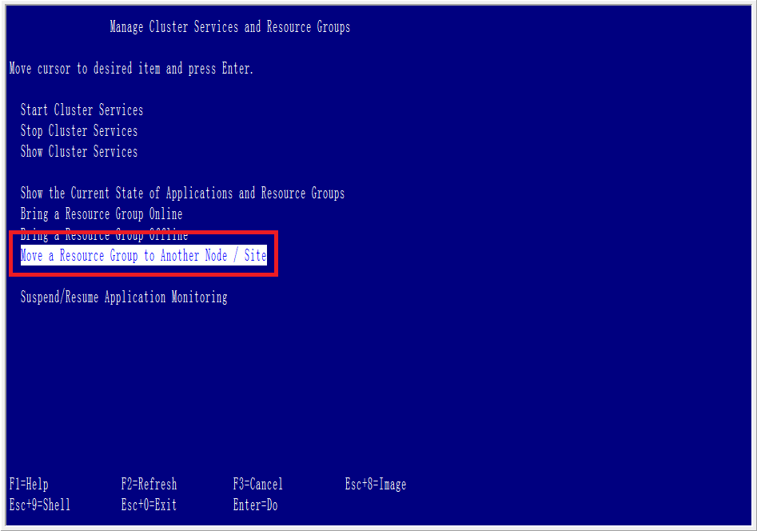

## LMS DR test

1. eClient test:

<http://tpcwx309/eclient/IDMLogon2.jsp>

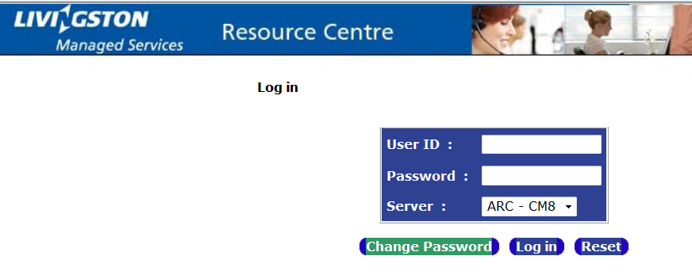

1. pClient test:

